**ONLINE STORE (**E-COMMERCE**)**

**T. TARUN KUMAR**

**REFINE WIREFRAMES**

* 1. **ALIGNMENT:**

The positioning and arrangement of items on a web page are referred to as alignment in web design. In order to create designs that are both aesthetically pleasing and user-friendly, proper alignment is essential.

* Visual Hierarchy
* Grid Systems
* Spacing and Grouping
* Reactive Alignment
* Accessibility

Keep in mind that alignment applies to all components, including buttons, forms, icons, and more. It is not only for text and pictures. When aligning items in web design, it's important to keep consistency, balance, and a clear visual hierarchy in mind.

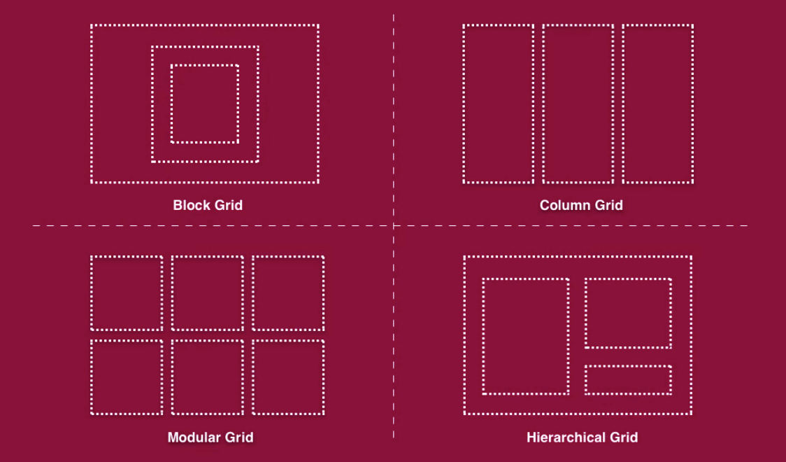

* 1. **SPACING:**

White space, commonly referred to as spacing, refers to the purposeful use of empty space between items in web design. A web page's information is organised and readability is improved with the use of proper space.

* Margins and padding
* Line Spacing
* Whitespace
* Content Grouping
* Reactive Space
* Resilience

Keep in mind that in web design, space is just as crucial as the parts themselves. It facilitates a unified layout, enhances readability, and directs users' focus. You may make a website design that is both visually beautiful and user-friendly by using the proper margins, padding, line spacing, and whitespace.

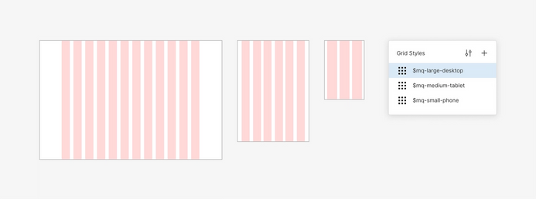

* 1. **TYPOGRAPHY:**

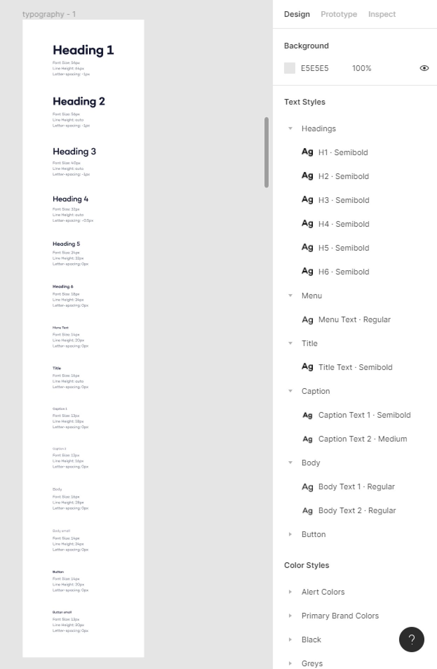

Typography, which involves choosing, arranging, and styling fonts on a web page, is essential to online design. A website's visual appeal, readability, and overall user experience may all be improved by using effective typography.

* Font Choice
* Size of the Fonts and Hierarchy
* Line Spacing and Length
* Formatting and Alignment
* Accessibility and Readability

The font on your website should be cohesive with the overall layout and convey the essence of your brand. You may build an efficient typographic design that improves the user experience on your website by carefully choosing typefaces, creating hierarchy, assuring readability, and taking responsiveness and accessibility into account.

* 1. **TYPOGRAPHY:**

In web design, establishing a visual hierarchy is essential for directing users' attention and offering a simple and straightforward user experience. Visual hierarchy describes how design components are arranged and presented so as to convey their significance and direct the viewer's attention through the text.

* Organisation of the Content
* Typography
* Contrast and colour
* Dimension and Size
* White Space 5.
* Visual Indicators
* 7. Grids and Layout
* 8. Media and Imagery

Remember that the purpose of a visual hierarchy is to effectively express the desired message, direct users' attention, and provide a seamless user experience. To optimise the visual hierarchy for your particular website or project, experiment with various design aspects and iterate depending on user input.

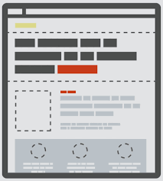

* 1. 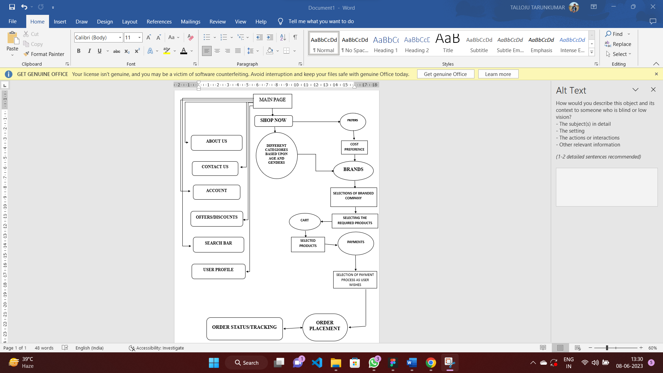 **INTENDED DESIGN:**

**ABOUT US:**

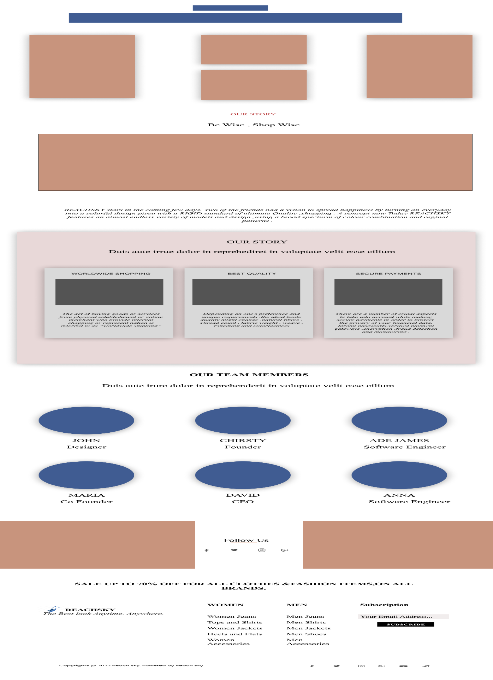

**CONTACT US:**

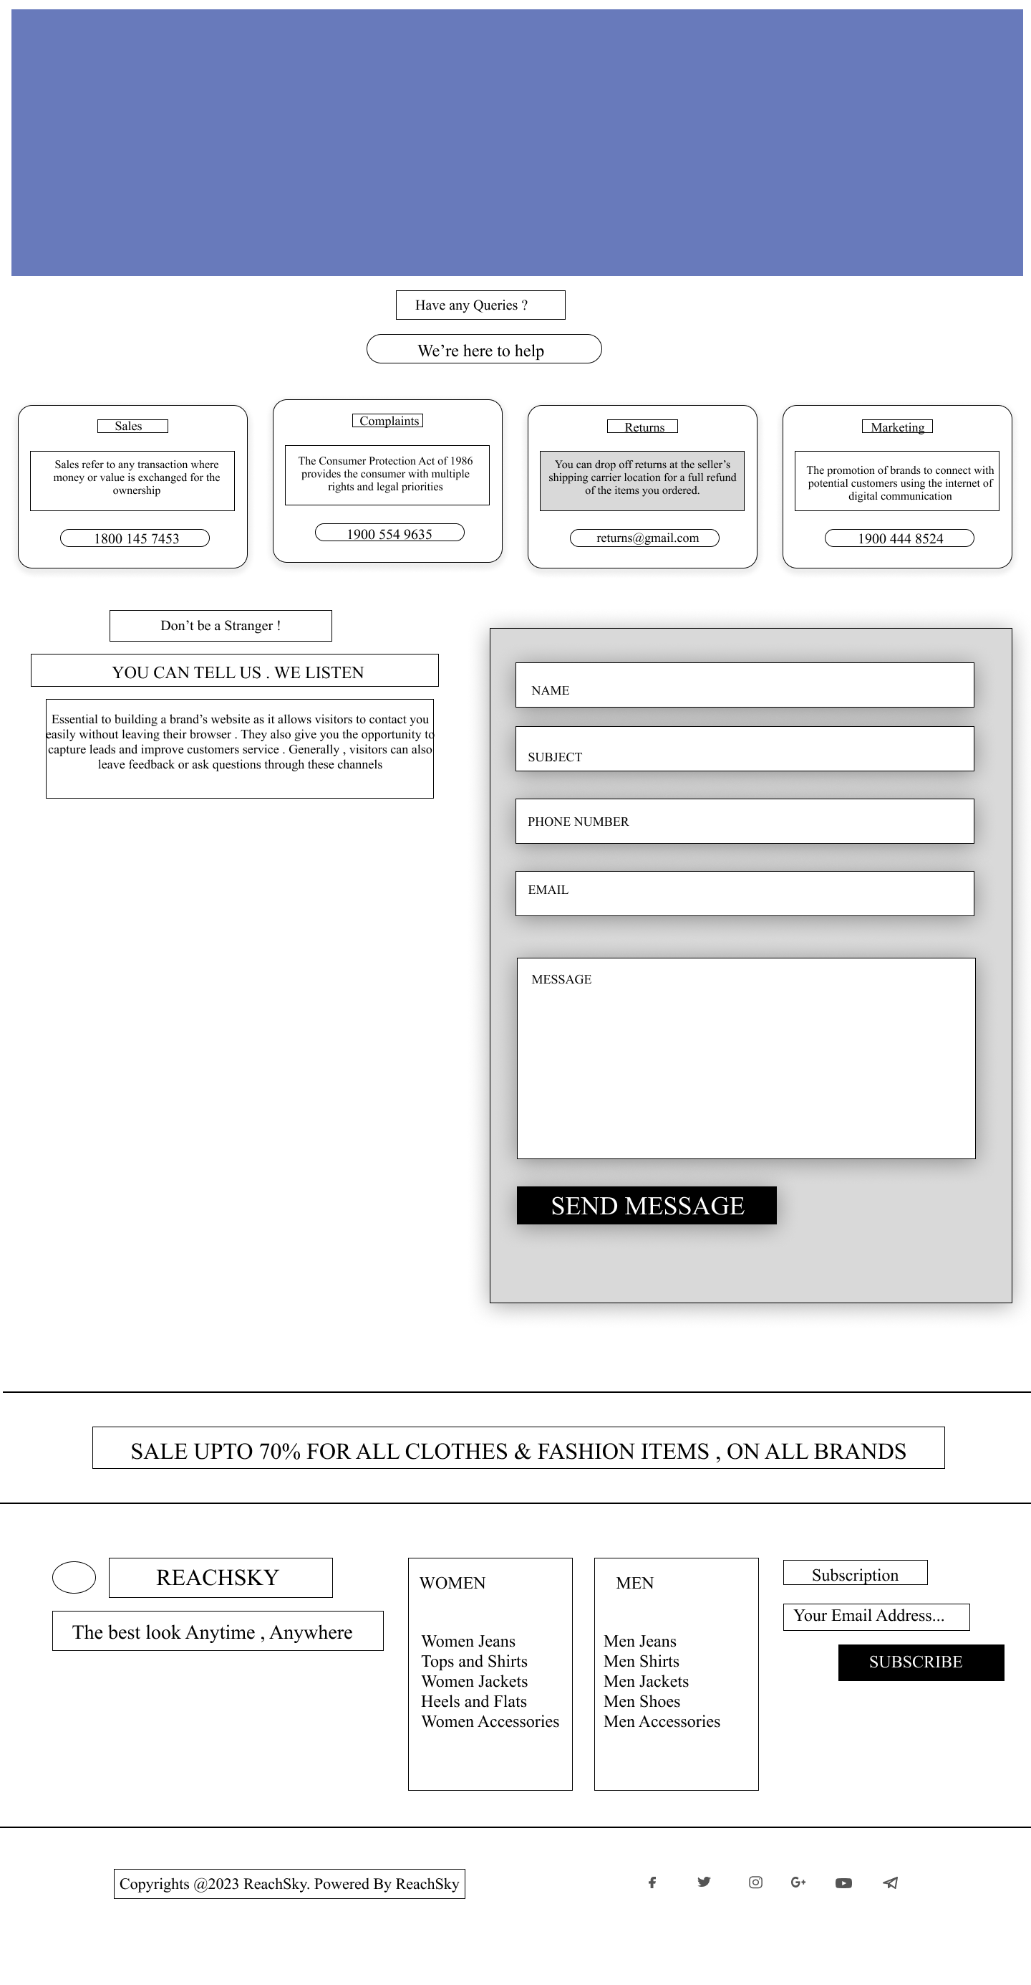

**PROFILE:**

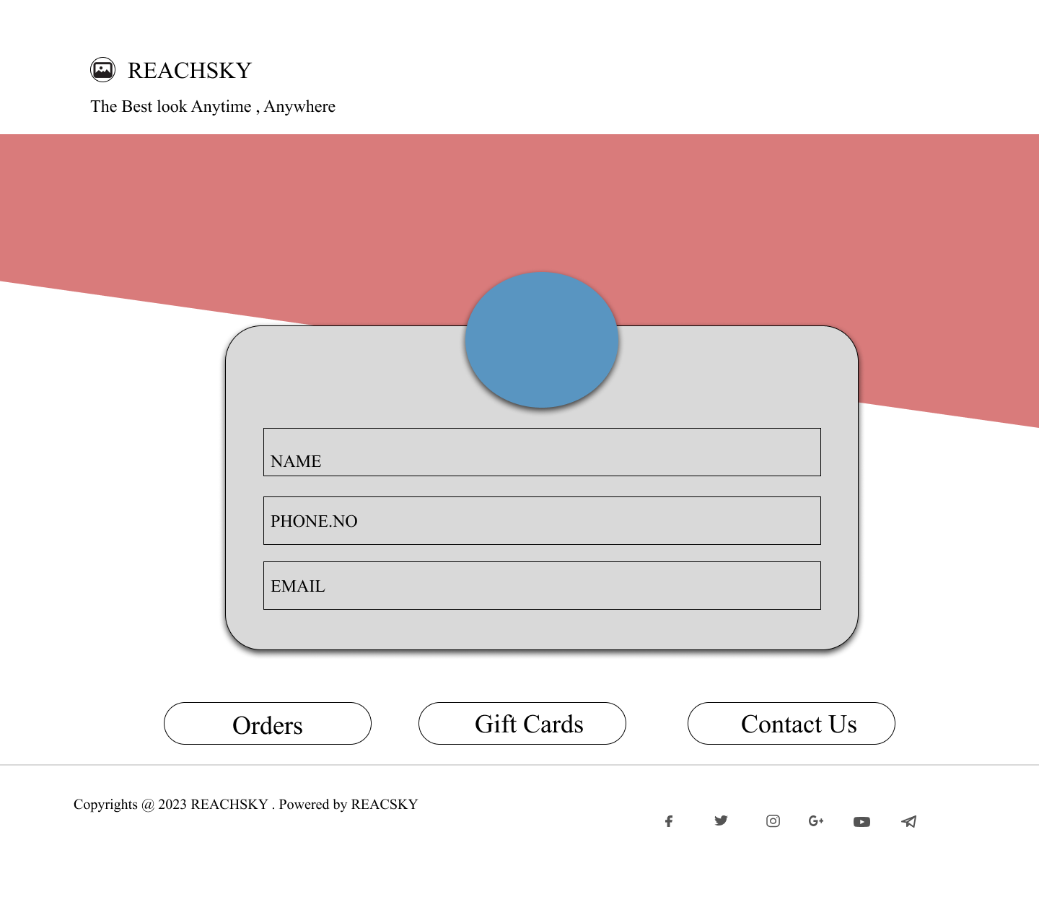

**ACCOUNT:**

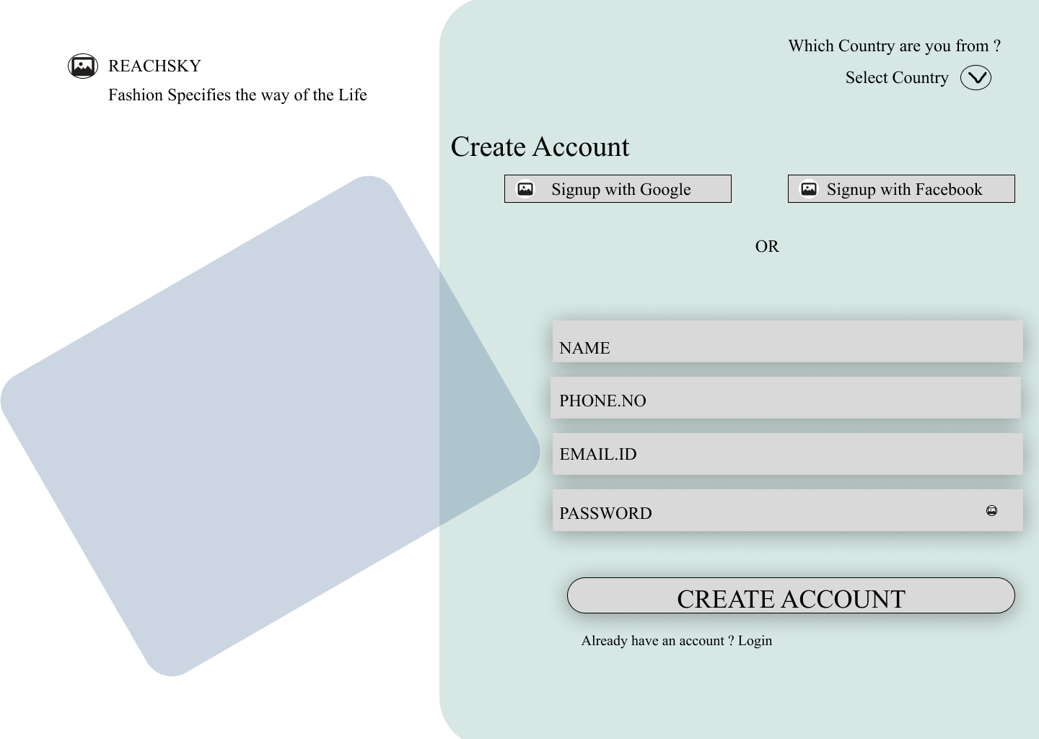

**OFFERS:**

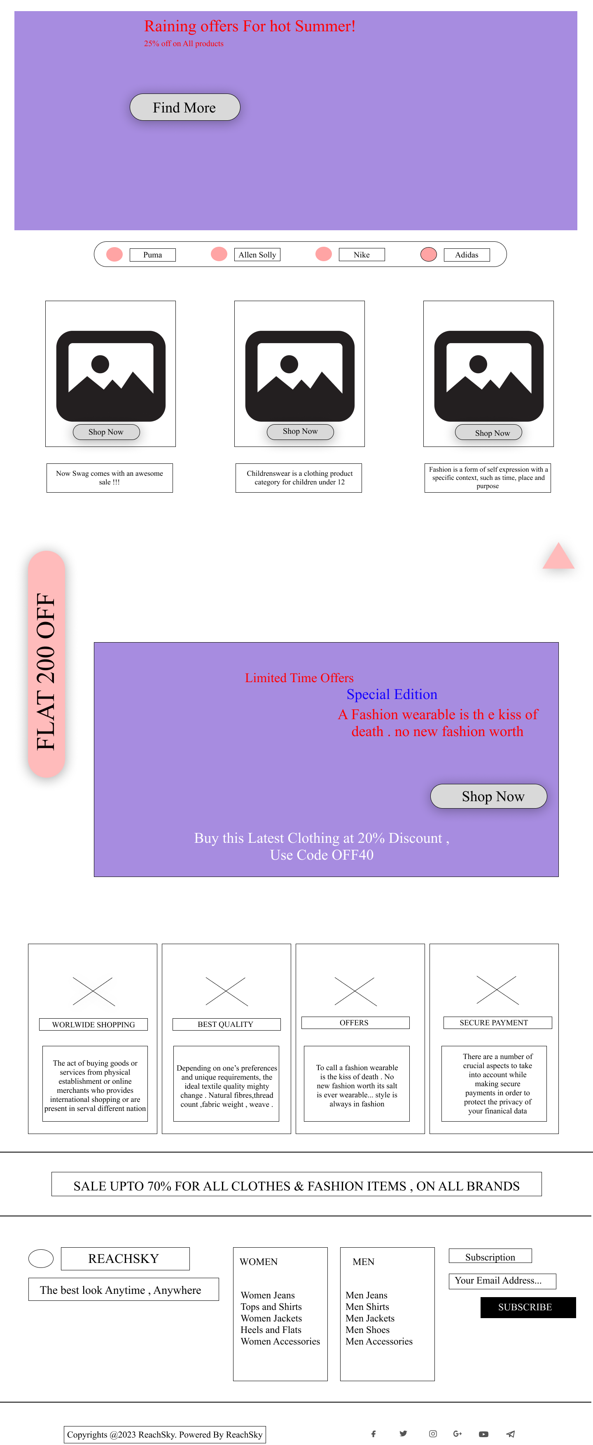

**SHOP NOW:**

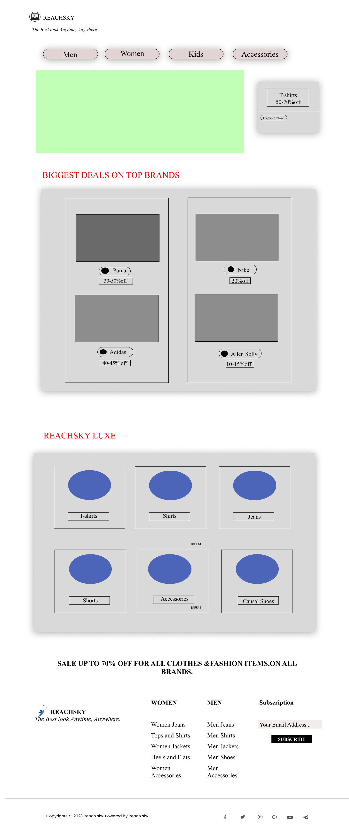

**DESIGN COMPONENTS**

**BUTTONS:**

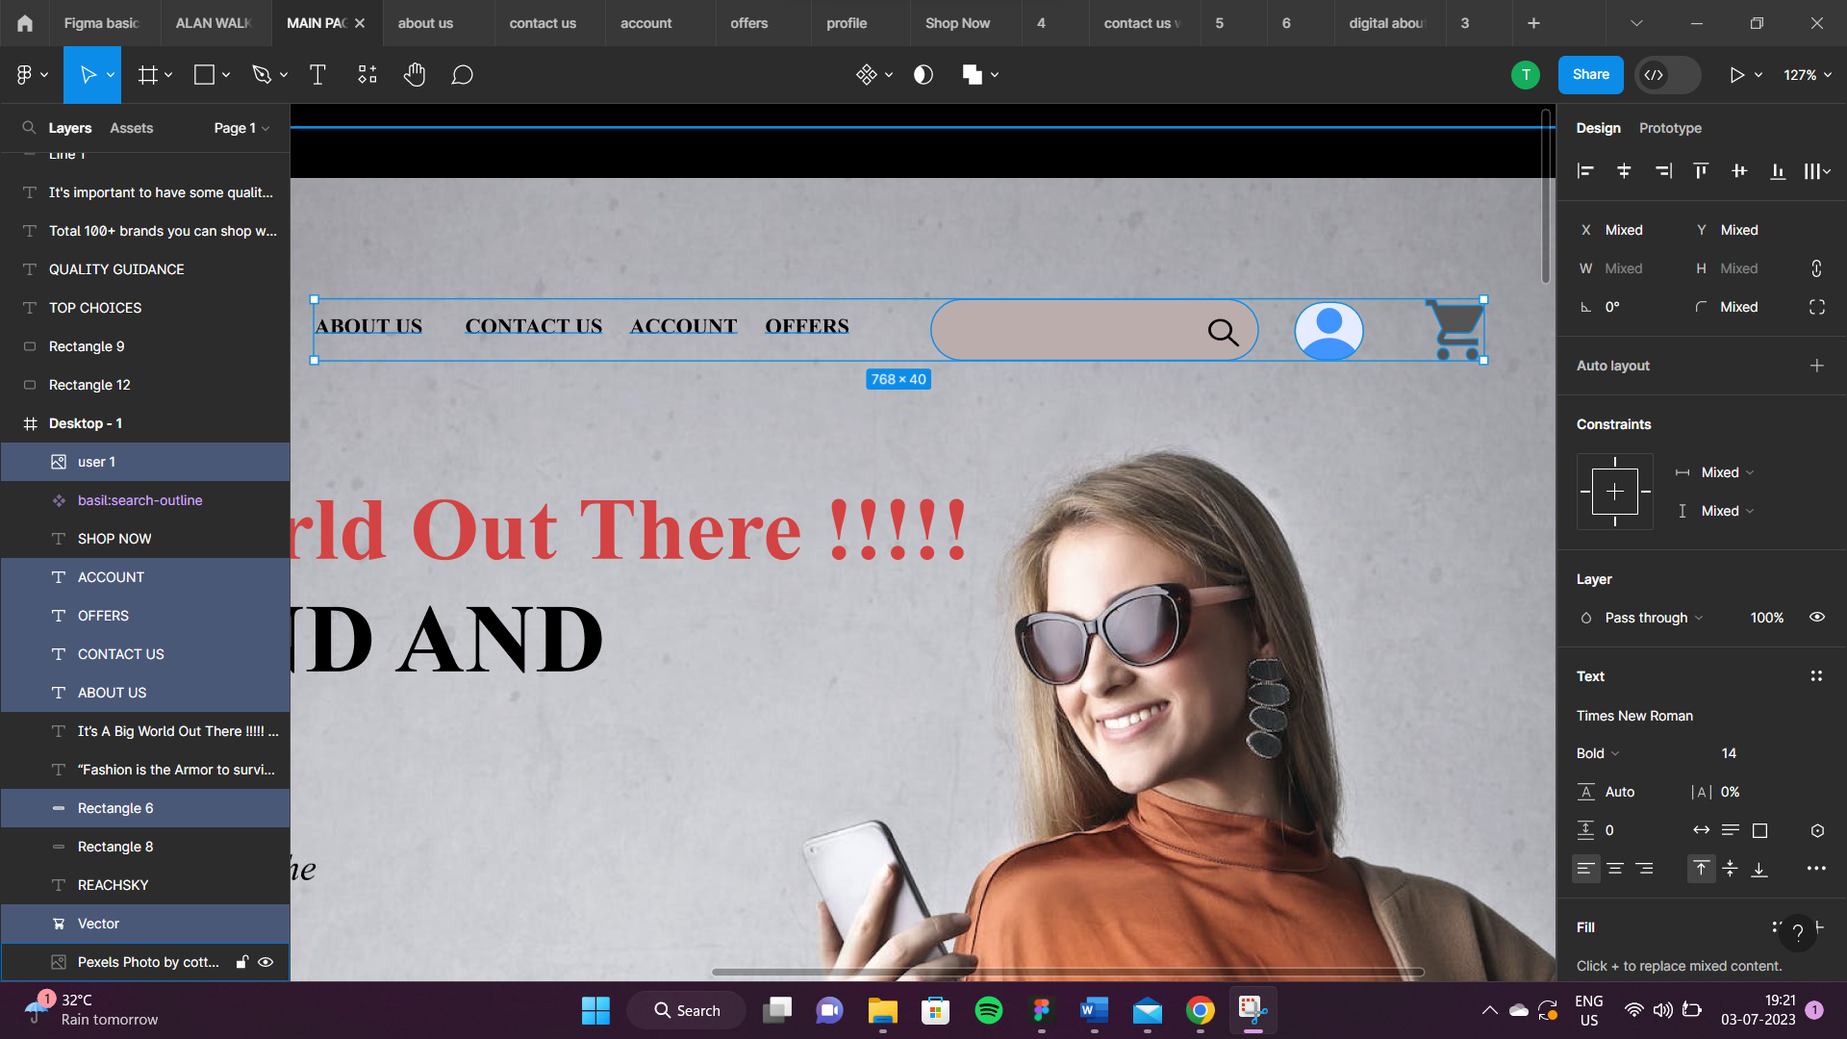

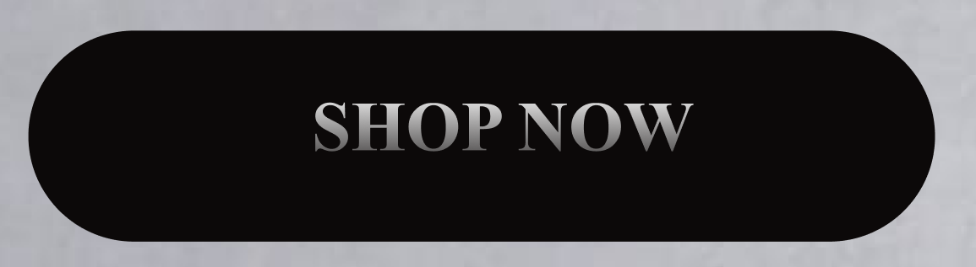









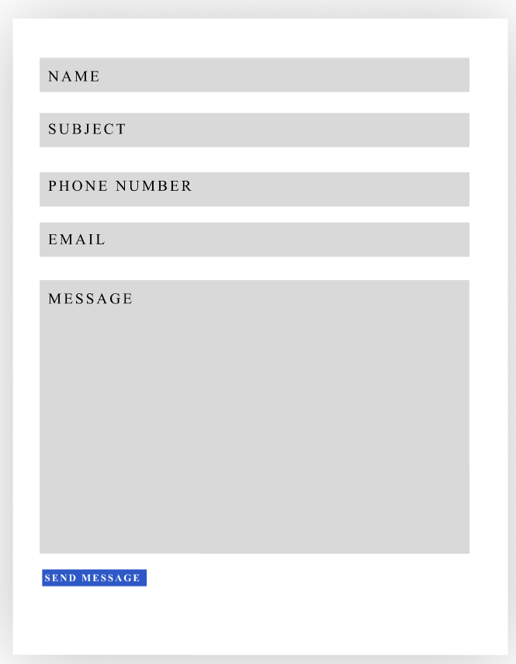

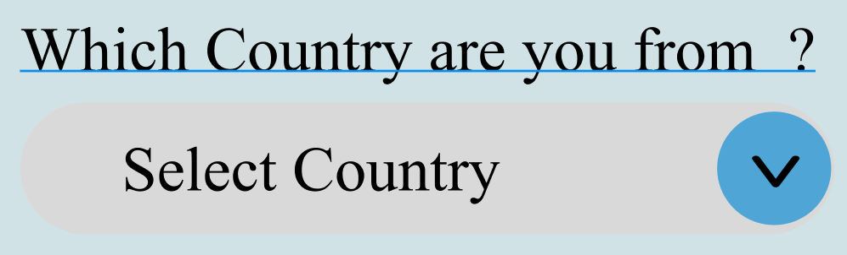







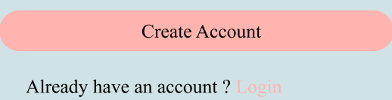

**NAVIGATION MENU:**

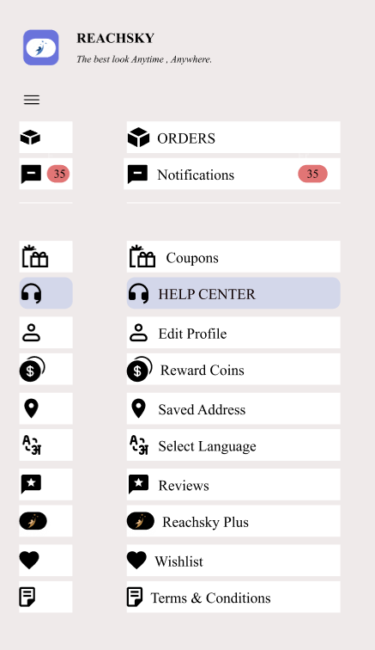

**INPUT FIELDS:**

